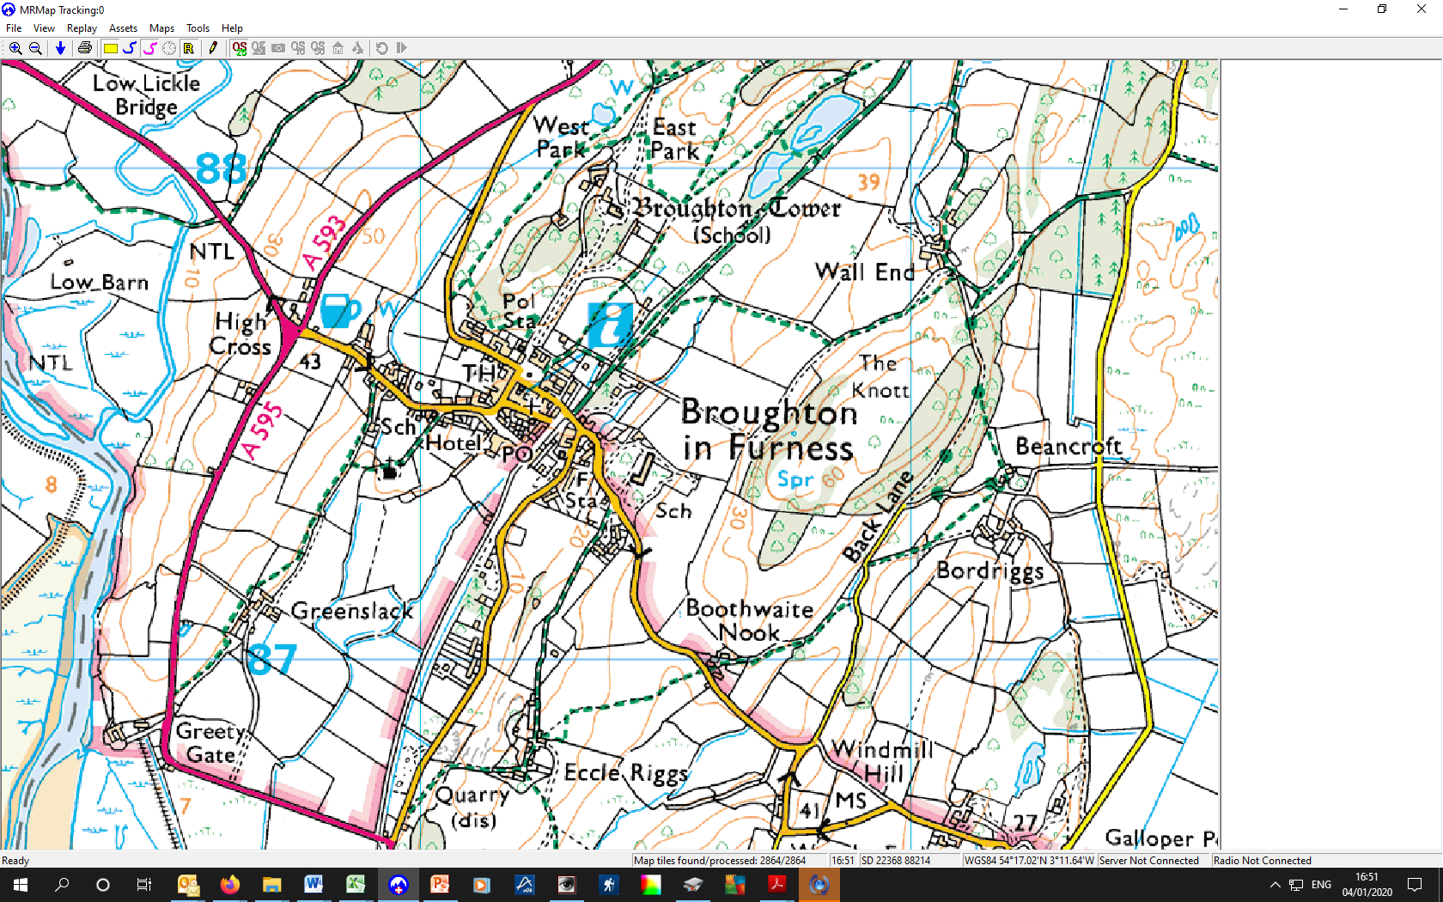

To Millom A595

To Coniston A593

To Foxfield A595

Barn

Miller’s Cottage

Market Square and Toilets

Eccle Riggs

Kepplewray and School

Coachman’s House

Broughton Tower

Quarry