Duddon Furnace Woodland Survey 2019

Surveys 4 and 5 MC and group Jan 15th and Jan 23rd

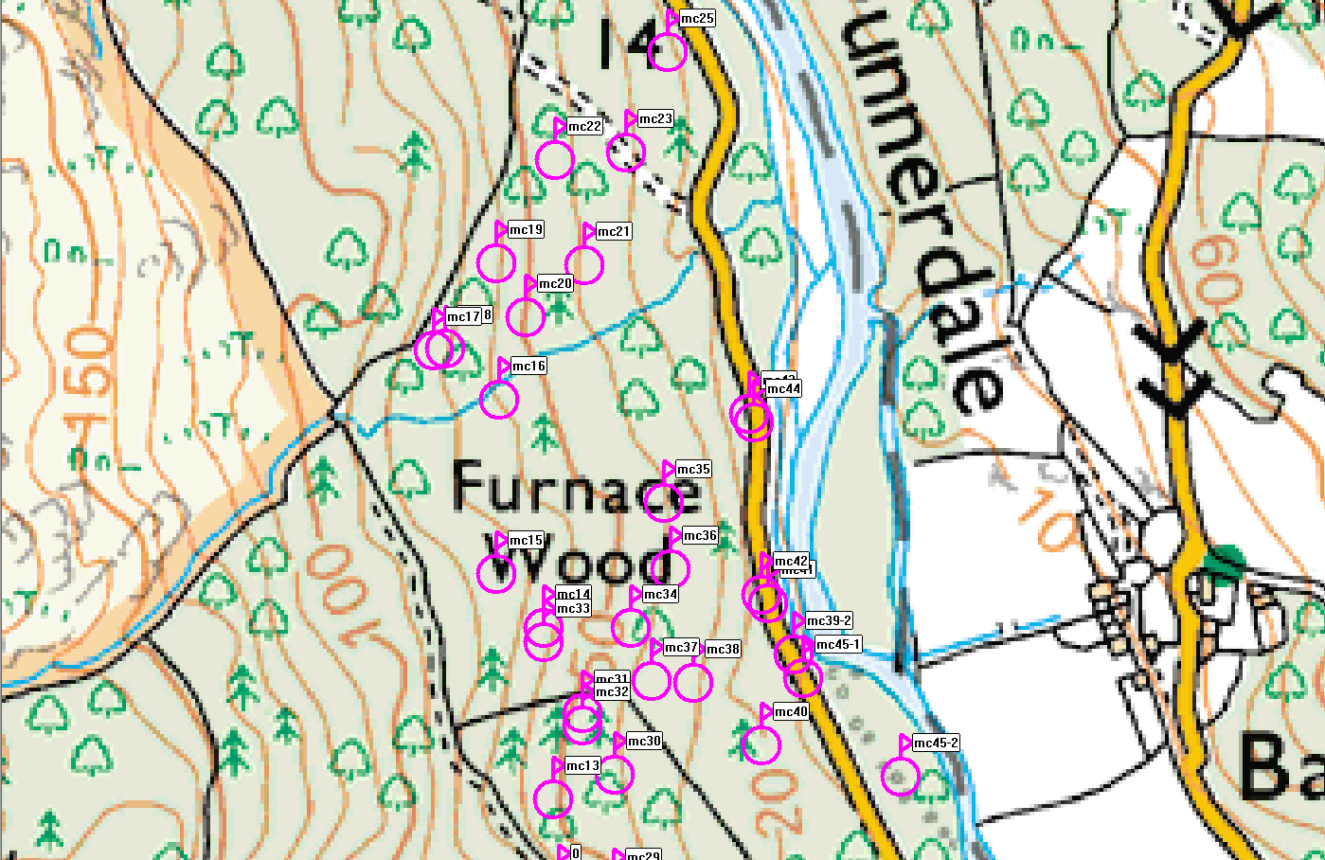

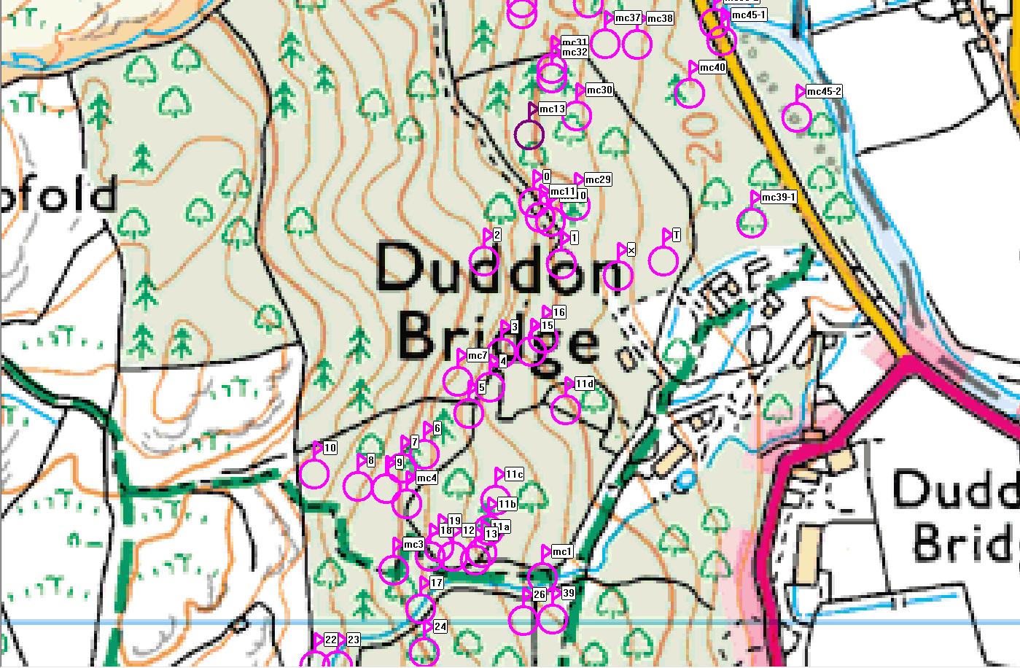

Ref | Northings | Eastings | Description
mc1 | SD19486 | 88036 | Cistern
mc2 | SD19396 | 88044 | Pitstead previous survey no 18
mc3 | SD19359 | 88042 | Pitstead
mc4 | SD19370 | 88098 | Stone hut
mc5 | SD19355 | 88125 | Pitstead previous survey no 7
mc6 | SD19407 | 88175 | Pitstead previous survey no 5
mc7 | SD19413 | 88201 | Pitstead
mc8 | SD19440 | 88229 | Pitstead previous survey no 3
mc10 | SD19491 | 88335 | Pitstead
mc11 | SD19482 | 88339 | Quarry
mc13 | SD19473 | 88048 | Pitstead
mc14 | SD19467 | 88519 | Pitstead probably duplicate of mc33
mc15 | SD19436 | 88554 | Pitstead
mc16 | SD19438 | 88667 | Pitstead
mc17 | SD19396 | 88699 | Pitstead
mc18 | SD19403 | 88700 | Potash pit?
mc19 | SD19436 | 88755 | Pitstead
mc20 | SD19455 | 88720 | Pitstead
mc21 | SD19493 | 88754 | Pitstead
mc22 | SD19474 | 88822 | Pitstead
mc23 | SD19520 | 88827 | Pitstead
mc25 | SD19547 | 88892 | Quarry
mc26 | SD19487 | 88301 | Pitstead previous survey no 1
mc29 | SD19512 | 88349 | Pitstead
mc30 | SD19513 | 88424 | Pitstead
mc31 | SD19490 | 88455 | Pitstead
mc32 | SD19492 | 88456 | Stone mound – potash kiln?
mc33 | SD19480 | 88514 | Pitstead probably duplicate of mc14
mc34 | SD19523 | 88579 | Pitstead
mc35 | SD19545 | 88600 | Pitstead
mc36 | SD19549 | 88557 | Pitstead
mc37 | SD19537 | 88485 | Potash pit?
mc38 | SD19564 | 88484 | Pitstead
mc39-1 | SD19660 | 88334 | Water leat
mc39-2 | SD19629 | 88502
mc40 | SD19608 | 88443 | Pitstead
mc41 | SD19612 | 88535 | Quarry
mc42 | SD19608 | 88541 | Pitstead
mc43 | SD19600 | 88658 | Pitstead
mc44 | SD19603 | 88652 | Pinnel hole?
mc45-1 | SD19635 | 88487 | Water leat
mc45-2 | SD19698 | 88423

