Duddon Furnace Woodland Survey 2019

Survey 3 DH/SC Jan 9th

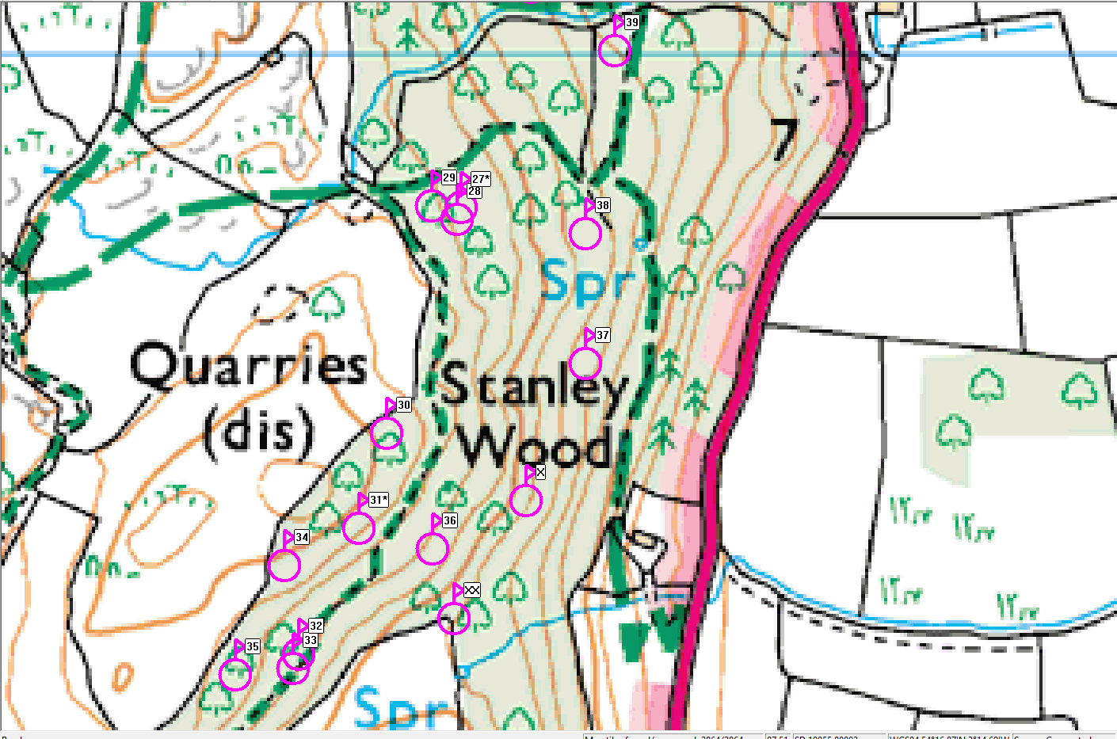

Ref | Northings | Eastings | Description
26 | SD19437 | 87938 | Pitstead good
27 | SD19374 | 87880 | Potash kiln
28 | SD19380 | 87874 | Pitstead very good
29 | SD19351 | 87882 | Pitstead very good
30 | SD19352 | 87693 | Pitstead very good by path
31 | SD19340 | 87764 | Bark peeler’s hut with fireplace
32 | SD19248 | 87534 | Pitstead very good
33 | SD19244 | 87523 | Pitstead possible close to wall
34 | SD19237 | 87603 | Pitstead possible
35 | SD19199 | 87518 | Pitstead moderate
36 | SD19342 | 87696 | Pitstead very good – large platform with circular hearth
37 | SD19470 | 87759 | Pitstead good
38 | SD19470 | 87860 | Pitstead good
39 | SD19425 | 87918 | Pitstead moderate
XX | SD19368 | 87562 | Lowest point of survey
X | SD19435 | 87226 | Lowest point of survey

