Duddon Furnace Woodland Survey 2019

Survey 2 DH Jan 4th

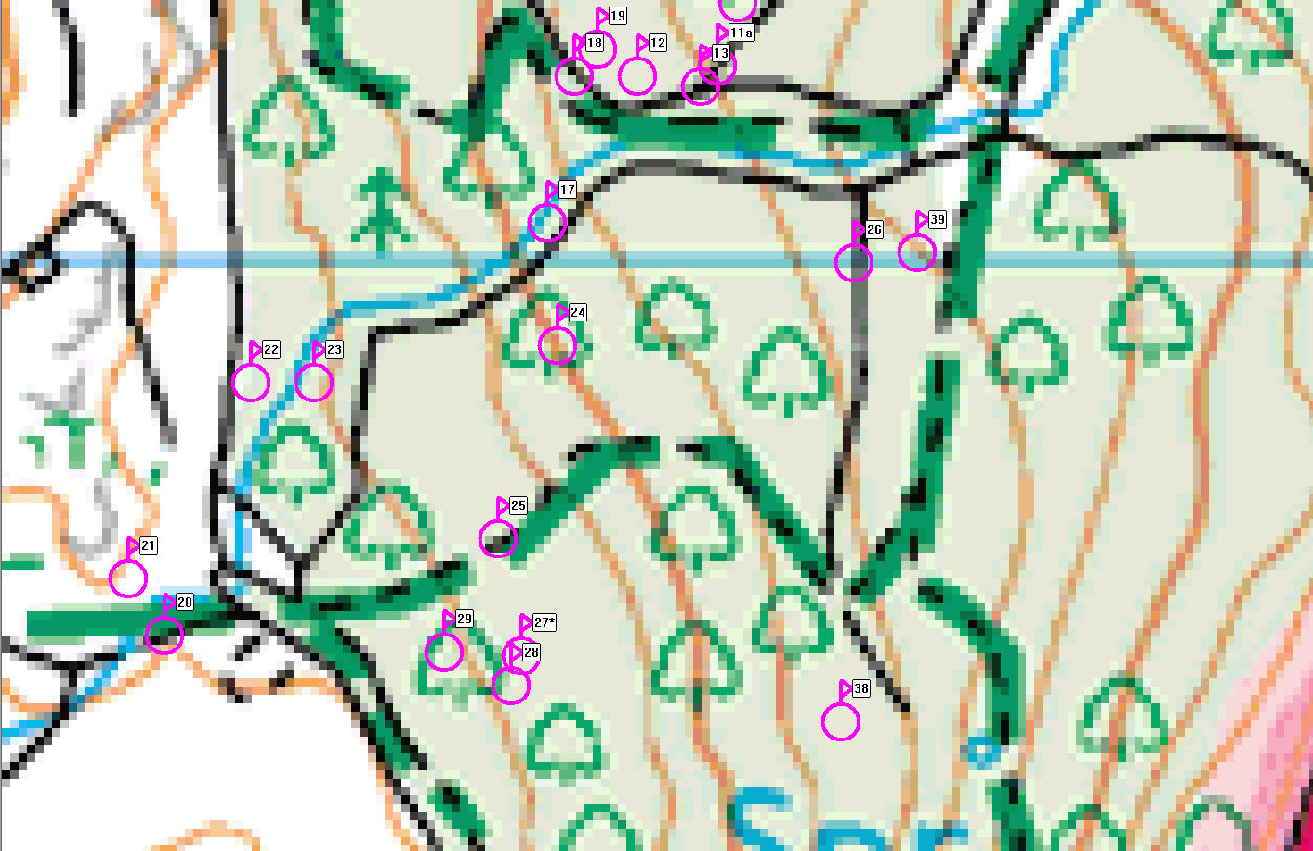

Ref | Northings | Eastings | Description
17 | SD19382 | 88010 | Pitstead very good
18 | SD19397 | 88062 | Pitstead flat area large stones could be revetment
19 | SD19397 | 88062 | Pitstead a short way off track
20 | SD19267 | 87886 | Pitstead very good
21 | SD19256 | 87903 | Pitstead very good
22 | SD19293 | 87962 | Pitstead very good
23 | SD19312 | 87962 | Gap/gateway in old wall
24 | SD19385 | 87943 | Pitstead good
25 | SD19367 | 87915 | Pitstead good
26 | SD19474 | 87988 | Pitstead very good with revetment above old wall

