Duddon Furnace Woodland Survey 2019

Jan 2nd

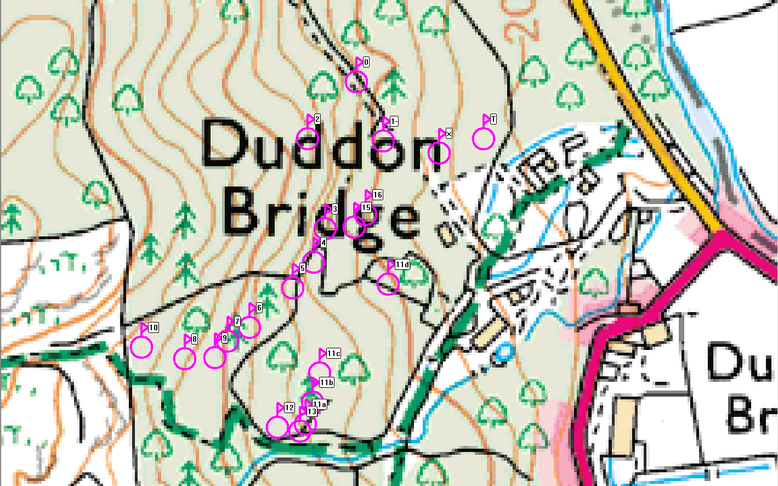

Ref | Northings | Eastings | Description
0 | SD19477 | 88351 | Edge of transect – beck crosses path
1 | SD19577 | 88347 | Pitstead ?
2 | SD19435 | 88302 | Pitstead
3 | SD19450 | 88225 | Pitstead good revetment
4 | SD19440 | 88196 | Pitstead good revetment
5 | SD19422 | 88174 | Pitstead good
6 | SD19385 | 88140 | Pitstead good revetment
7 | SD19366 | 88128 | Pitstead good banked
8 | SD19329 | 88113 | Pitstead very good
9 | SD19355 | 88114 | Pitstead ???
10 | SD19292 | 88126 | Building, gabled end 1.5m², corrug iron roof, window hole 30cm²
11a | SD19433 | 88057 | Start of wall/embankment
11b | SD19433 | 88076 | Highest point of wall/embankment
11c | SD19445 | 88051 | Break in wall/embankment for track to gate
11d | SD19504 | 88177 | End of wall/embankment unclear
12 | SD19409 | 88054 | Sloping platform built up above wall height
13 | SD19428 | 88051 | Modern gate
14
15 | SD19475 | 88226 | Pitstead good
16 | SD19485 | 88237 | Pitstead moderate
X | SD19548 | 88290 | Crossing track from buildings
T | SD19584 | 88302 | T junction with track above charcoal store

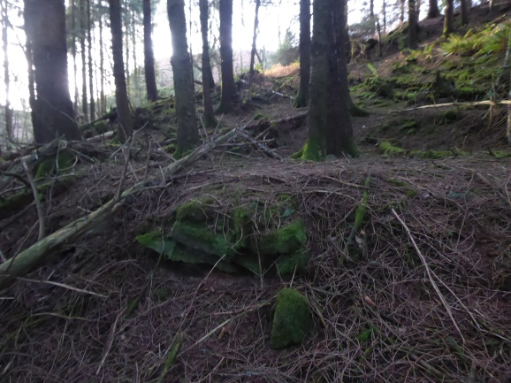

No 8 – revetment to pitstead

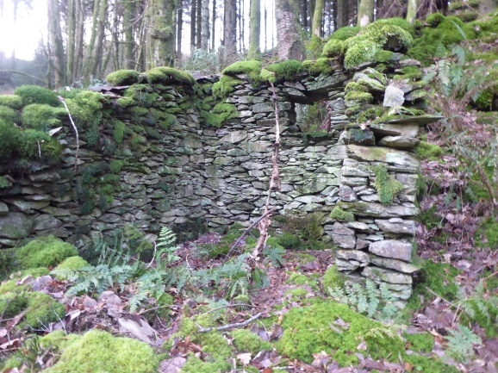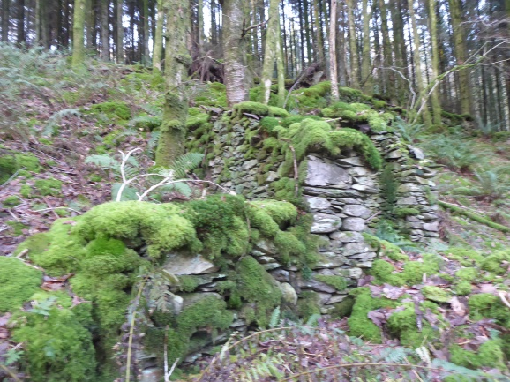

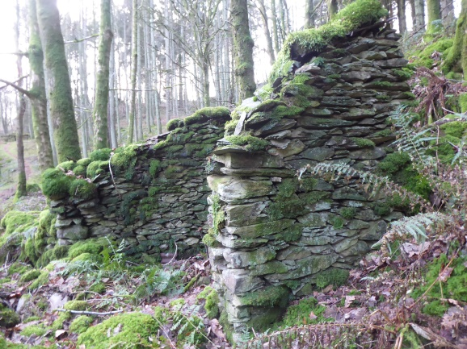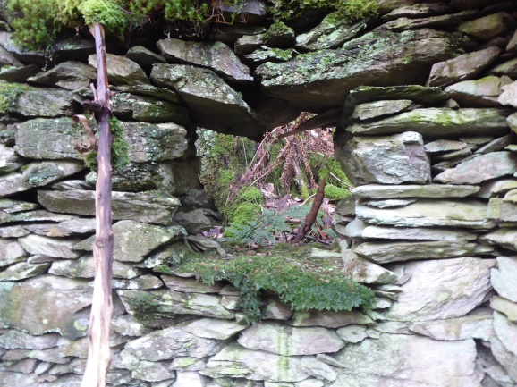

No 10 – building, open fronted with window and fragments of corrugated iron on roof

