Who built them and when?
After the Romans left Britain, most people lived in single room round houses until the “Vikings” came and settled. They brought a different house design that was rectangular.
The longhouse pattern was probably introduced to Britain by Norse settlers in about 800 A.D. Before that time, most people lived in single-roomed round houses. However, the longhouse design was so successful that it was copied for hundreds of years by country people in much of western Britain. A few longhouses probably remained in habitation until the 18th century, but most fell into disuse in the late medieval period (16th century).
How were they constructed?
A low wall was built out of stone with a wooden framed roof resting on top. The wall would often have been filled with turf and the roof thatched.
Longhouses were generally constructed of low drystone walling no higher than about 1-2 metres. Sometimes the walls were doubled to provide some insulation, and the space between may have been filled with turf. The walls at either end were generally built up into triangular gables. Wooden rafters rested on the walls and formed a pitched roof which was thatched with whatever materials came to hand, probably dry bracken, reeds or grass. It is thought that the rafters sometimes overhung the walls to provide external storage. The two basic rooms were separated by a cross-passage through which both people and their livestock would have entered. In some longhouses, the two rooms were separated by a simple partition, while in others there were cross-walls with doorways.
Where are they found and how were they used?
Longhouse ruins are found along the west coast of Britain but only in remote places where they have not been disturbed by modern farming. The Norse farmers would have kept animals and may have grown crops.
Remains of these buildings can be found throughout western Britain, from the northern Scottish isles all the way to Cornwall. In most of lowland Britain their traces have long since disappeared, but many can still be found in the uplands in various states of decay. Longhouses have been found throughout Cumbria, and at least 10 have been found in the Duddon Valley where they are generally found on the valley sides in situations which would not now be considered suitable for
farming. It is thought that they were generally used by livestock farmers, although some are associated with ploughing marks known as rig and furrow, indicating that some arable crops were grown.
Why are we excavating longhouses?
Not much is known about the early settlers and we hope that the excavation will find evidence of when the houses were built and about the people who lived in them
Only a few longhouses in Cumbria have been excavated, although an early one was excavated in the Lickle Valley at Stephenson Ground in the 1980s, and another was partially excavated more recently at Tonguesdale Moss in Eskdale. However, a building proven to have been occupied by the early medieval Norse settlers of Cumbria has not yet been discovered. The prime objective of the present excavation project is to look for evidence with which three of the Duddon Valley longhouses (in Tonguehouse High Close, and Longhouse Close) can be dated, and also to look for evidence about how their inhabitants lived, what they ate, and what sort of livestock they kept.
Where can I find more information?
The Vikings are studied in the National Curriculum so googling “Viking longhouses” will bring up lots of links for more information suitable for younger readers
A detailed report on our pre-excavation longhouse surveys in the Duddon Valley was published in 2013 and can be downloaded from our website www.duddonhistory.org.uk . A paper based on this report has also been published in an archaeological journal (Matthiessen et al., 2015, Transactions of the Cumberland and Westmorland Antiquarian and Archaeological Society 15, 117-138). Results of the current excavation programme will be published on the website from time to time. Reconstructed or restored buildings similar to longhouses can be visited in several places including the Isle of Lewis in the Outer Hebrides, and in the Dartmoor area.

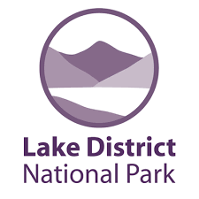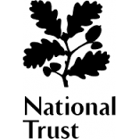
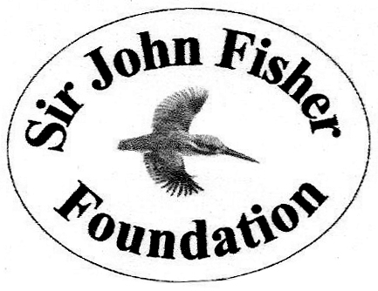
More questions (raised by children)
They look much smaller than the ones we’ve seen on school TV
Really long longhouses were probably occupied by the local chief, but the ones we are excavating would have been lived in by simple farmers.

How many people would have lived in one longhouse?
They would probably have housed four to six people – two parents and perhaps four children, but there was room under the roof for a few more!

Where did they go to the toilet?
Not in the house – there was no bathroom! They probably had a small wooden outhouse with a pit beneath.

What did they eat and how did they cook it?
This is one of the questions we hope will be answered by the dig. However, they probably grew a little barley or rye to make bread, and would have made butter and cheese from the milk of their livestock. They probably only ate meat rarely, although their diet may have been supplemented by hunting. They cooked on an open fire in the middle of the main room, and the smoke leaked out through the thatch – there was no chimney.

Were there still wolves?
There were a few wolves left when the Norse settlers arrived, but most had been hunted out by then. Wolves were a threat to livestock and so would have been killed if seen in the neighbourhood.

Why are the field walls so low? Would they keep anything in or out?
It seems that the cattle in those days had quite short legs and it didn’t take much of a wall to keep them penned in.

When did we stop calling them Vikings, and what did we call them then?
The Norse settlers of the Lake District would probably not have called themselves Vikings as they had become peaceful farmers. However, we do not know for sure what they were called by the earlier inhabitants of Britain, although if they were still around today they would doubtless call themselves Cumbrians

THE DUDDON DIG
Excavating medieval longhouses in the Duddon Valley
Frequently Asked Questions
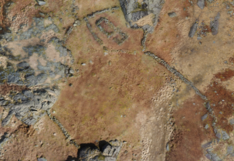
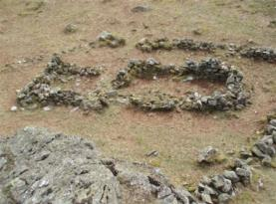
What are longhouses?
A longhouse was a type of simple farm building in two sections for people and animals that was common before the stone farm houses that we see today were built.
Longhouses were a type of single-storey rectangular farmhouse which fell out of use in most parts of Britain several hundred years ago. In their simplest form, they consisted of two rooms separated by a cross-passage, although additional rooms might be added for storage etc. The farming family lived in one room, and their livestock inhabited the other during the winter. This arrangement, although smelly, helped to keep the living quarters warm as air was free to circulate. It was a common belief that the animal smell was effective in preventing diseases.

